**Project Report**

Submitted by

Manish Guduri



**Department of Computer Science and Engineering**

**SRM University-AP, Andhra Pradesh, India**

**October - 2021**

|  |  |  |
| --- | --- | --- |
| DATA SHEET | | |
| Name of the student | : | MANISH GUDURI |
| Branch & Section | : | CSE H |
| Batch | : | 2019-2023 |
| Type of internship | : | Industrial Training |
| Company Name/Institute Name | : | Andhra Pradesh State Skill Development Corporation (APSSDC) |
| Company/Institute Website | : | https://engineering.apssdc.in/ |
| Start Date (MM/DD/YYYY) | : | 06-07-2021 |
| End Date (MM/DD/YYYY) | : | 07-14-2021 |
| Duration (No. of days) | : | 38 |
| Status of the internship | : | Completed |
| Signature of the student | : | G. Manish |

**Introduction**

In the present world we are generating huge amount of data through which we can make some business decisions and to predict future outcomes. So, this internship is helpful in building ML models for the given data. "Data science using python internship" is organised by APSSDC. This is 38 days internship organised from 07-06-2021 to 14-07-2021.

This project is totally based on the concepts we learnt in data science internship.

We have used the following resources:

Platform/Software: Jupiter Notebook

Language Used: Python

Concepts: Python, Data science, Machine learning

As our project is house loan approval prediction, it is a classification model. So, we make logistic regression, decision tree classifier, random forest classifier and extra trees classifier.

**Logistic regression:**

Logistic regression predicts the output of a categorical dependent variable. So the outcome must be in the format of Yes or No, 0 or 1 etc, true or False, etc. Logistic Regression is much similar to the Linear Regression except that how they are used. Linear Regression is used for solving Regression problems, whereas Logistic regression is used for solving the classification problems.

**Random Forest Classifier:**

Random forest is a commonly-used machine learning algorithm, It can be used for both Classification and Regression problems in ML. It combines the output of multiple decision trees to reach a single result.

**Decision Tree Classifier:**

Decision tree is the most powerful and popular tool for classification and prediction. A Decision tree is a flowchart like tree structure, where each internal node denotes a test on an attribute, each branch represents an outcome of the test, and each leaf node (terminal node) holds a class label.

**Extra Tree Classifier:**

It is also called **Extremely Randomized Trees Classifier**. Extra Trees Classifier is an ensemble learning method fundamentally based on decision trees. Extra Trees Classifier, like Random Forest, randomizes certain decisions and subsets of data to minimize over-learning from the data and overfitting

**Out Comes:**

* After this project we are able to find the identify the difference between classification and regression models.
* We understood how the null values effect our model results.
* We understood how to train the data and test the data.
* We increased problem solving skills and programming capability.

**Flow Chart:**

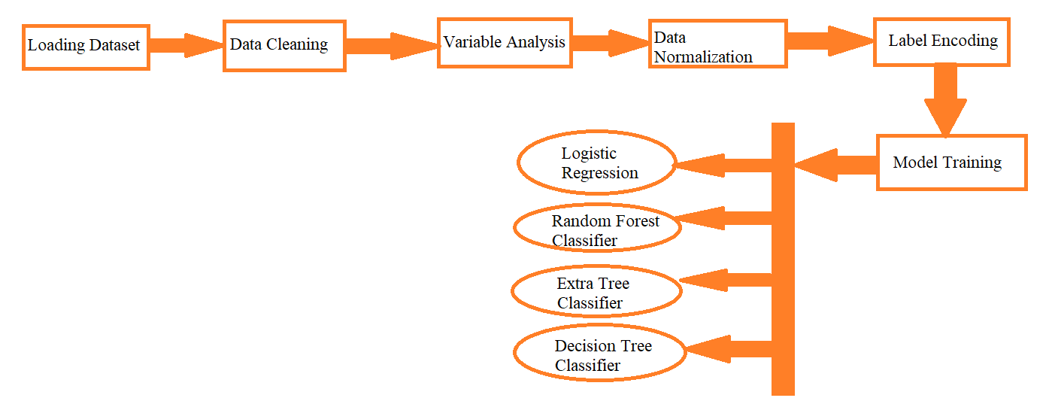

**Graphs:**

**Gender:**

By looking the graph we can analyse that The number of male present are approx. 500

And the female present are approx.-120

**Marrital status:-**

Around 400 are married and 215 are unmarried

**Employment:-**

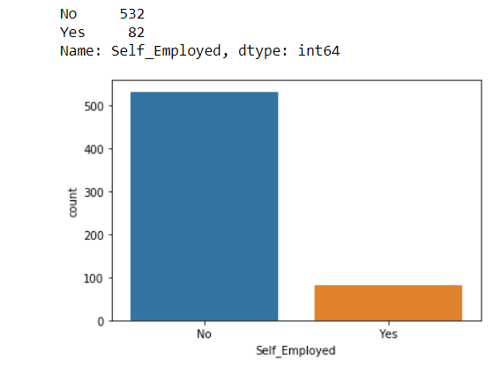

We can see majority of them are not self employed they are nearly:532

And 82 people are employed

**Dependents:-**

**Education:-**

**Credit history:-**

**Property area:-**

**Correlation Matrix:-**

This correlation graph tells the relation between two variables.

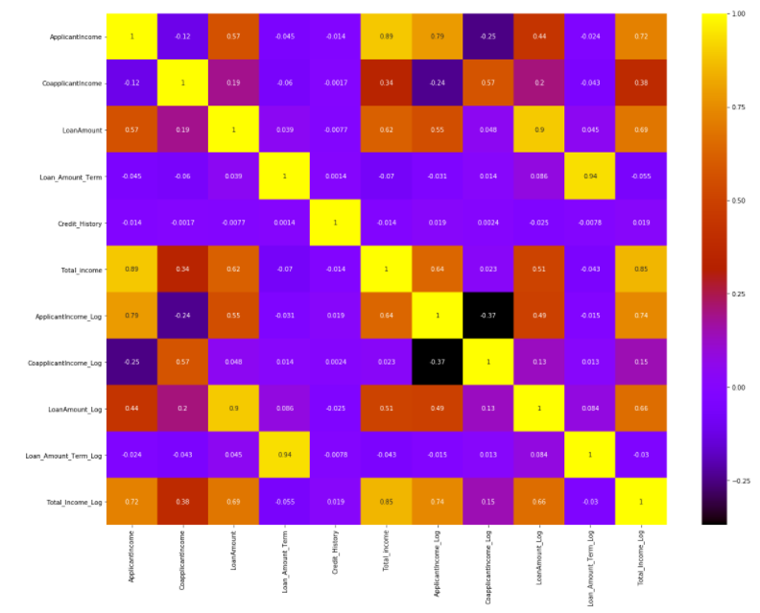

**Result:**

As the data set is classification model we used logistic regression, Decision Tree classifier, Random-forest classifier, Extra Tress classifier by doing all these classifications we got best accuracy for logistic regression.

By doing this project we understood how this classification is working. We can predict weather the person is eligible for getting loan or not by giving some inputs like education, graduation, marital status etc this will tell us to approve the loan or not.